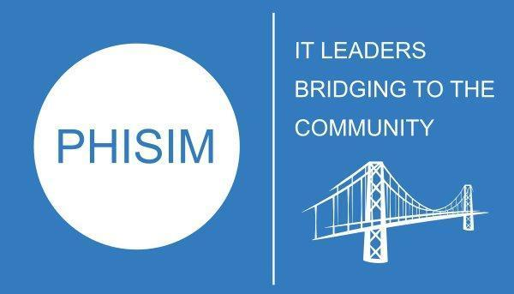 | PHILADELPHIA PHILANTHROPIC SOCIETY  FOR INFORMATION MANAGEMENT FOUNDATION INC

2026 PHISIM SCHOLARSHIP PROCESS

UNIVERSITY QUALIFICATION
Friday, January 30, 2026 | New academic members attest to their institution’s meeting the qualifications .Existing members are reviewed every three years.  PHISIM reviews the institutions' qualification forms and approves those institutions which meet the criteria.
STUDENT NOMINATIONS
Friday, February 13, 2026 | Qualifying institutions submit their student nominee's information
Friday, February 27, 2026 | Student nominee submits his/her testimonial and photo
STUDENT RECOGNITION
Tuesday, April 7, 2026 | Scholarship students are presented at the SIM Philadelphia Chapter Meeting

